# **DPS920/CVI620 – Lab 5**

# **Edges and Lines**

| Total Mark: | 10 marks (3% of the total course grade)   * 6 out of 10: Learn@Seneca submission (Due: Wednesday October 11th end of day) * 4 out of 10: Lab demo (Due: During Lab of week 6) |
| --- | --- |
| Submission file(s): | * Lab05_1.py / Lab05_1.ipynb * Lab05_2.py / Lab05_2.ipynb * Lab05.docx |

Please work in **groups** to complete this lab. This lab is worth 3% of the total course grade and will be evaluated through your written submission, as well as the lab demo. During the lab demo, group members are *randomly* selected to explain the submitted solution. Group members who are not present during the lab demo will lose the demo mark.

Please submit the submission file(s) through Learn@Seneca. ALL team members must submit the final work.

***Please paste the resulting images and answers in this document.***

## **Part I: Edge Detection**

1. Write code in Lab05_1 to
   1. Open ‘credit’ image and convert it to greyscale. Display the greyscale image (paste the result here).



* 1. Use the OpenCV Sobel function to find the edges on the image. Use a Sobel filter. Display the results for the following parameters as well as two output datatypes, i.e., CV_8U and CV_64F (paste results here):
* dx =1 , dy = 0
* dx =0 , dy = 1
* dx =1 , dy = 1

What do you notice for datatypes? What do dx and dy show? Explain.

* dx =1 , dy = 0

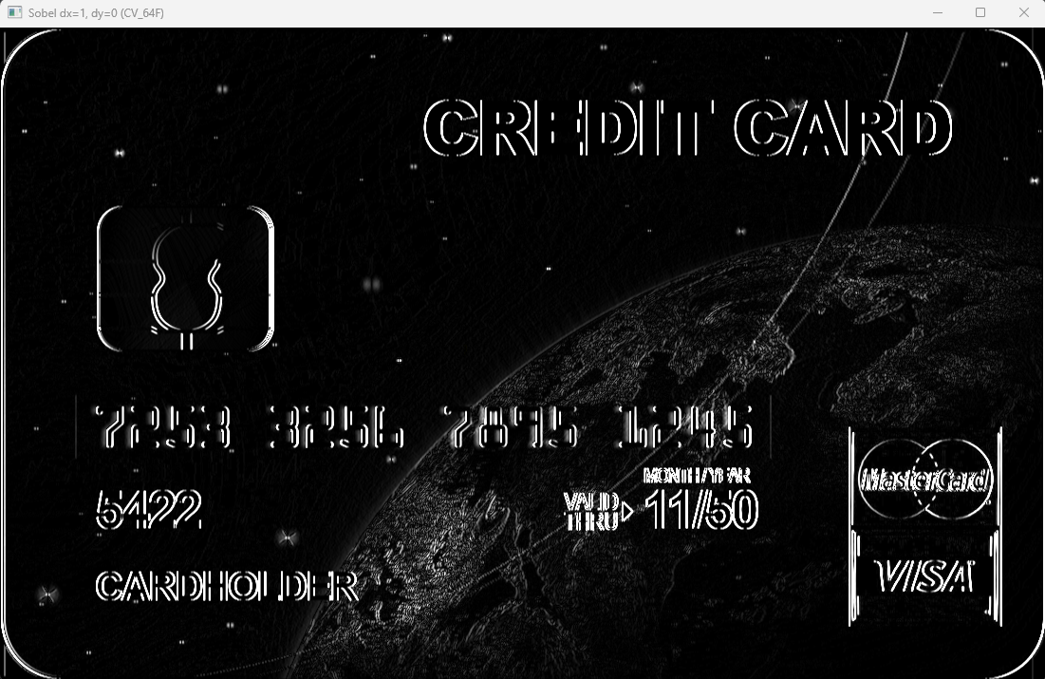

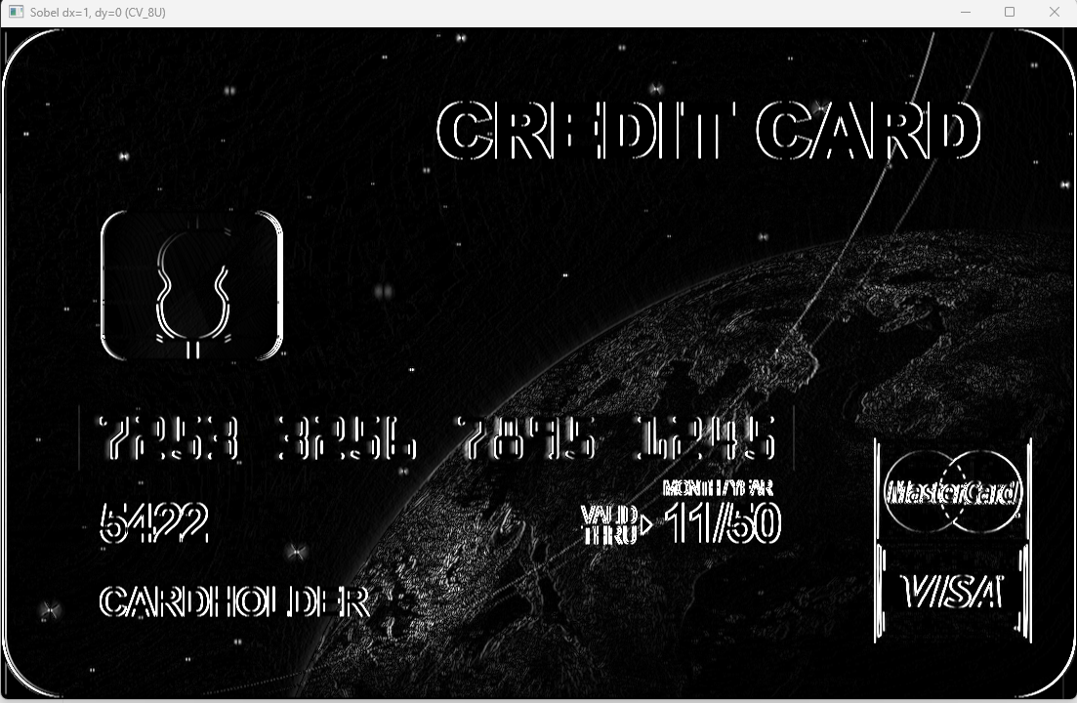

* dx =0 , dy = 1

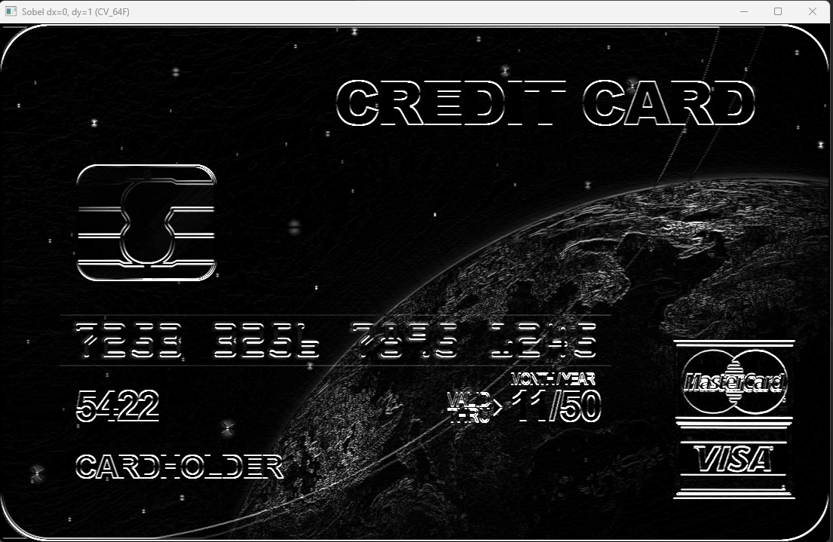

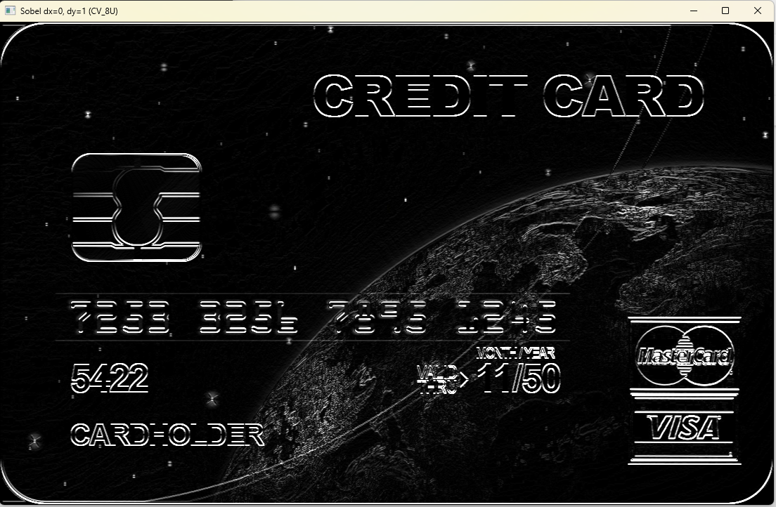

* dx =1 , dy = 1

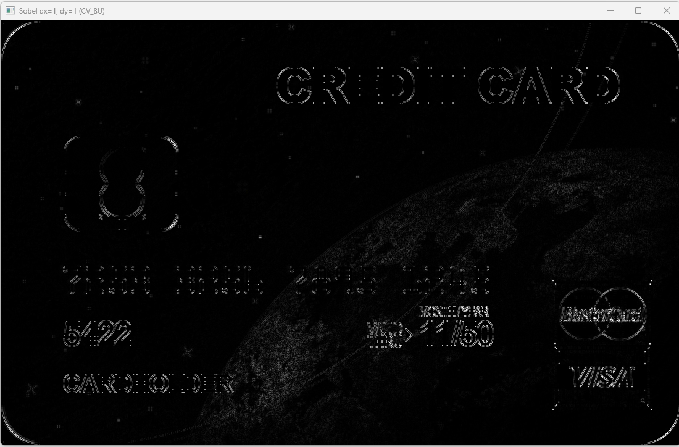

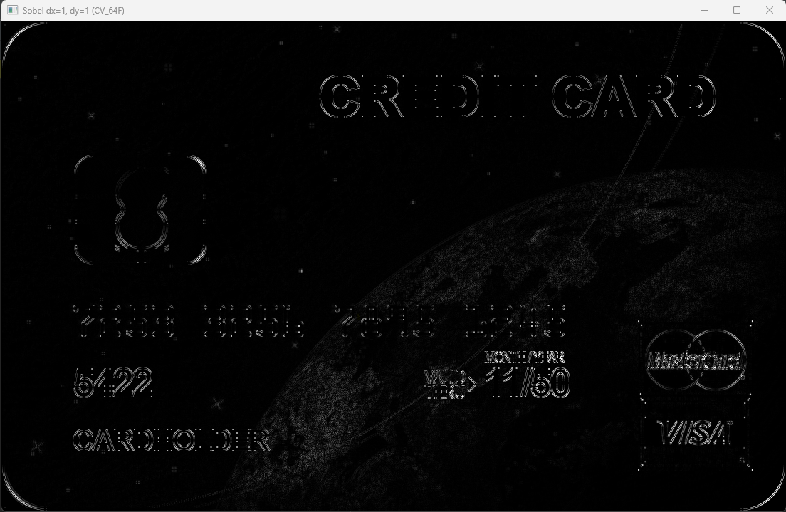

**What do you notice for datatypes? What do dx and dy show? Explain.**

CV_8U: This datatype is an 8-bit unsigned integer format. When using this format for edge detection with the Sobel operator, the output range is limited between 0 and 255. As a result, any values that fall outside this range are either clipped or wrapped around. This can lead to artifacts in the image, especially when there are strong edges.

CV_64F: This datatype is a 64-bit floating-point format. When using this format, the output range is not restricted, allowing for a broader range of values. This can result in more accurate representation of edge strengths. However, for visualization purposes, the output values are often normalized to the range [0,255] to make them visible.  
  
In Sobel edge detection, `dx` and `dy` parameters define the direction in which the gradient is calculated.

dx = 1, dy = 0: This configuration detects edges that are vertical in the image. The Sobel filter is applied in the x-direction, emphasizing changes in intensity from left to right.

dx = 0, dy = 1: This configuration detects edges that are horizontal in the image. The Sobel filter is applied in the y-direction, emphasizing changes in intensity from top to bottom.

dx = 1, dy = 1: This configuration combines the effects of the previous two, detecting edges in both the x and y directions. This results in a more comprehensive edge map, capturing both vertical and horizontal edges.

* 1. Compare your result for (b) with the result of applying a Canny edge detector. Experiment with different threshold values and display the results.

Paste two samples here.

How is threshold changing the results?

Then, explain how is the Canny map different from the previous maps?

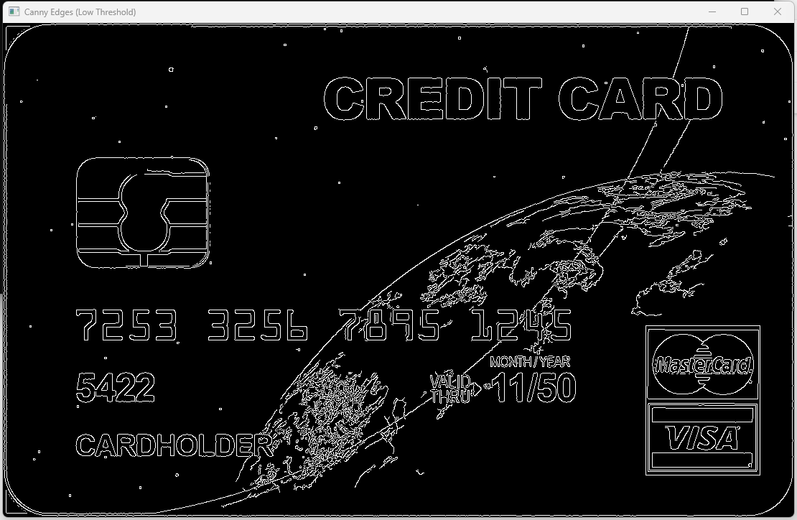

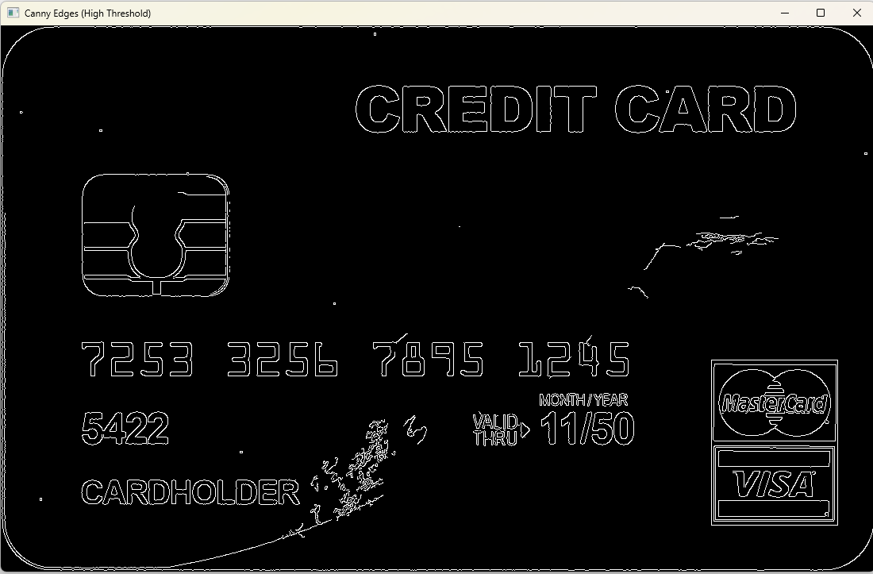

**How is threshold changing the results?**

In Canny edge detection, the threshold values (`canny_low_threshold` and `canny_high_threshold`) control which edges are considered strong or weak.

Lower values for both thresholds result in more edges being detected, including weaker edges. Higher values detect only strong edges. Increasing the threshold values generally reduces the number of detected edges, making the detection more stringent.

Lower thresholds can be used when you want to detect subtle edges or when there's noise in the image. Higher thresholds are useful when you want to detect only prominent edges.

**Then, explain how is the Canny map different from the previous maps?**

The Canny edge detection map is different from the Sobel maps in several ways:

* Binary Output: The Canny edge detector produces a binary image where pixels are either classified as edges (white) or non-edges (black), based on the thresholding.
* Edge Tracking: Canny includes an edge tracking algorithm to connect weak edges to strong edges, resulting in continuous edges.
* Non-Maximum Suppression: It performs non-maximum suppression to thin out edges and keep only the most prominent ones.
* Double Thresholding: Canny uses double thresholding to classify edges into strong and weak, allowing for better control over edge detection.
* Hysteresis: Canny employs hysteresis to decide which weak edges to include based on their connectivity to strong edges.

In contrast, the Sobel filters provide gradient magnitude information for edges in specific directions, and their output is not binary. They do not handle edge tracking or hysteresis.

## **Part II: Line Detection**

1. Create a program (save as Lab05_2). Include code to:
   1. Open the “Building” image and convert to greyscale*.* Display the greyscale image.
   2. Use the Canny edge detector for the next step. Which threshold values did you use? (Paste the result here).

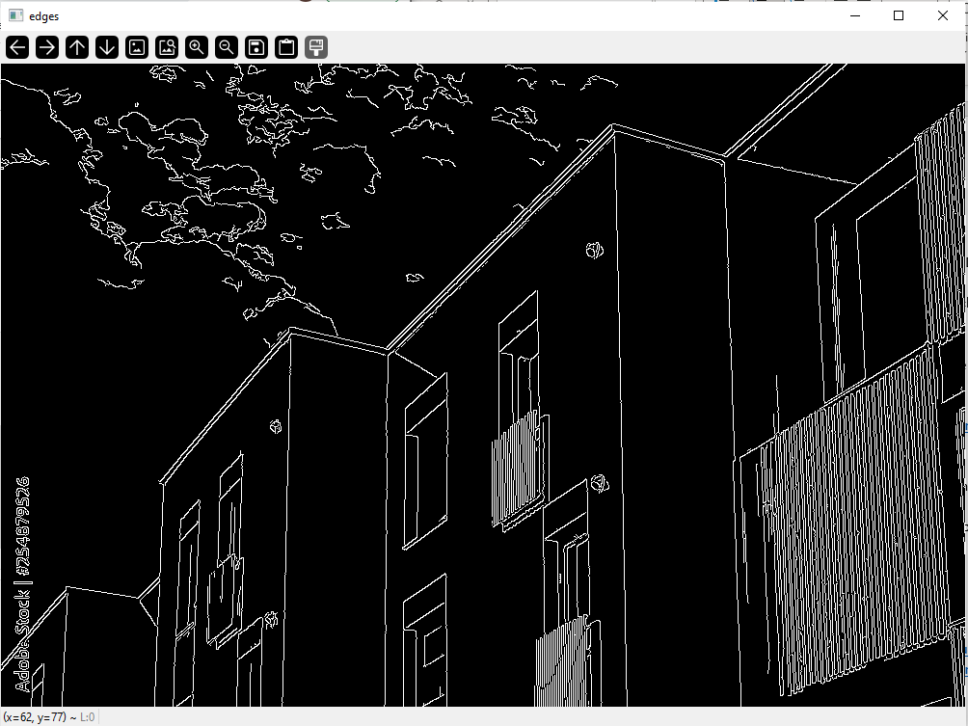

We used threshold values 70 and 210. These values allow us to capture the building edges and ignore majority of the clouds.

* 1. Use the Hough transform to detect lines in the image and display lines on the image.

Hint: You can use this link to start:

<https://learnopencv.com/hough-transform-with-opencv-c-python/>

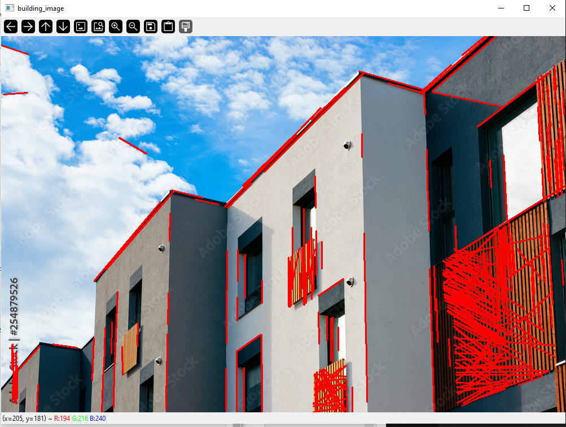

* 1. Then implement a loop in which you can increment the threshold and see the lines on image for various values of the threshold. Paste the resulting image with lines for 3 different threshold values. Then explain what threshold does.

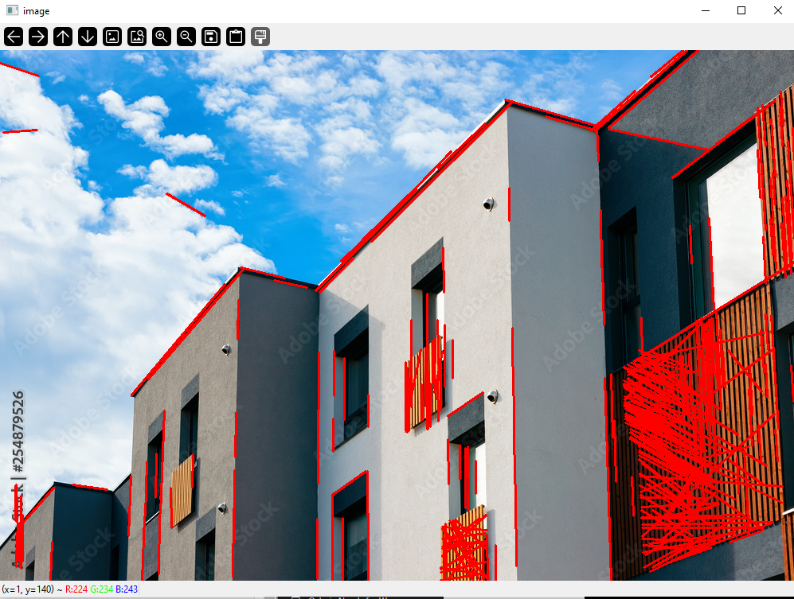

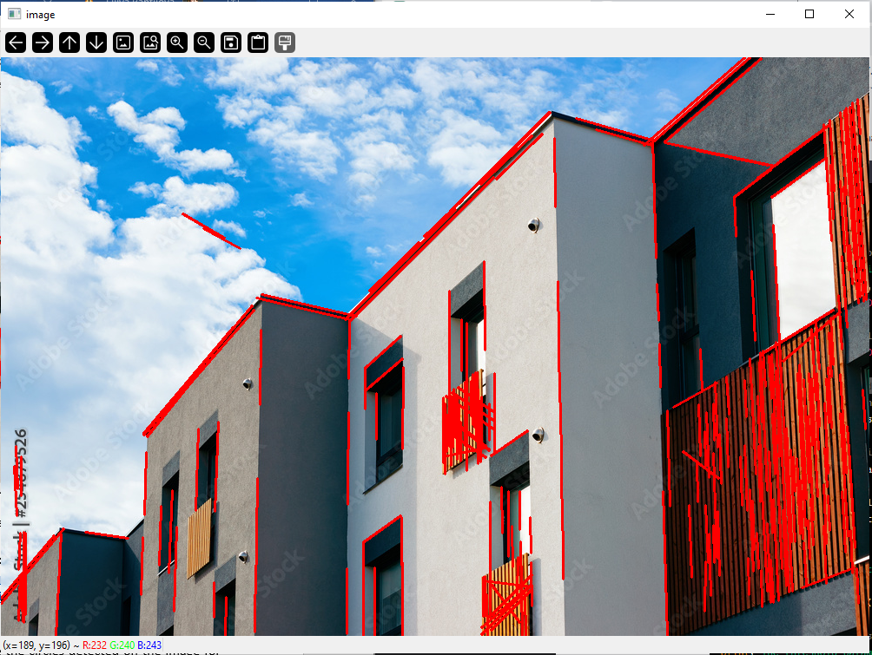

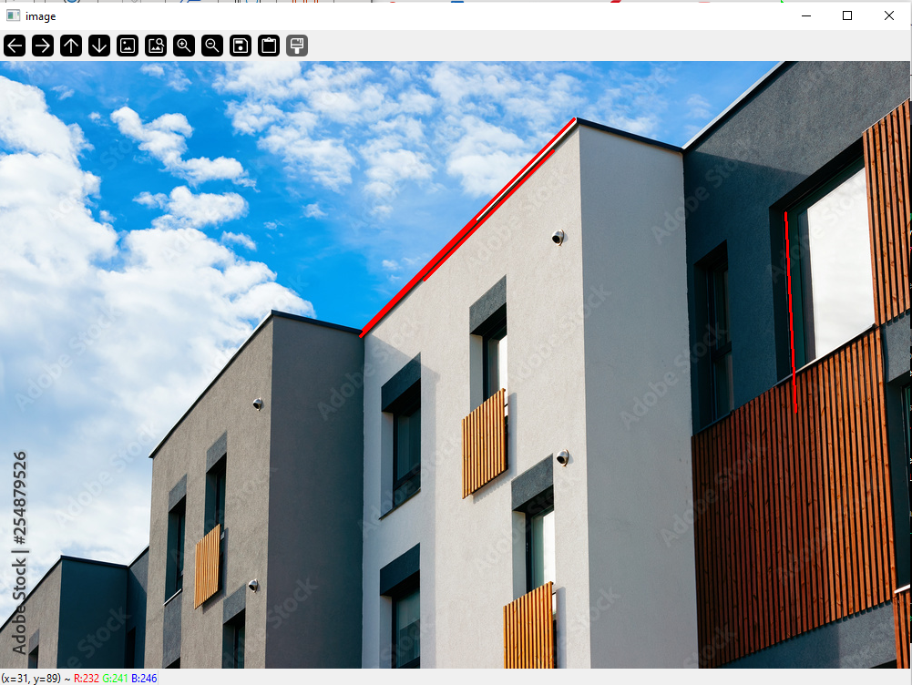

The higher the threshold, the less lines are being detected.

* 1. Use the Hough transform to detect the circles in the “Shapes” image and display on the image.

Hint: You can use either of these links to start:

<https://docs.opencv.org/4.x/da/d53/tutorial_py_houghcircles.html>

<https://learnopencv.com/hough-transform-with-opencv-c-python/>

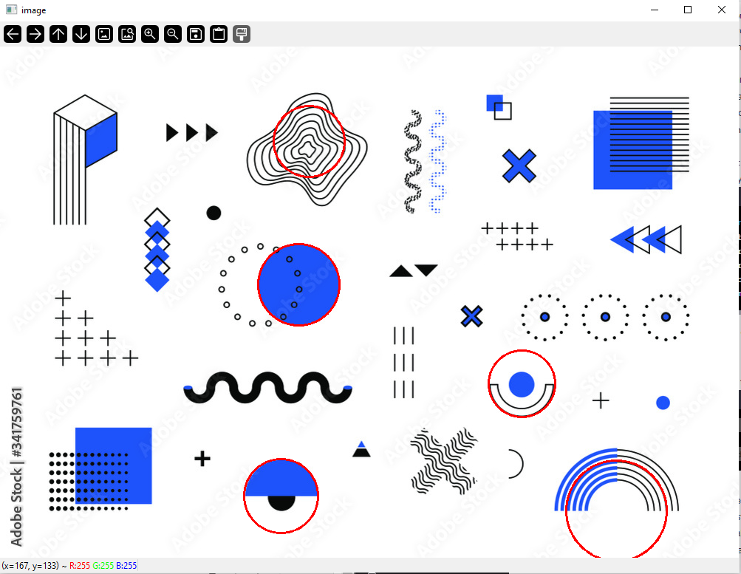

* 1. Then implement a loop in which you can see the circles detected on the image for various values of minDist and maxRadius. Paste the resulting images with circles.

minDist=10

maxRadius=50

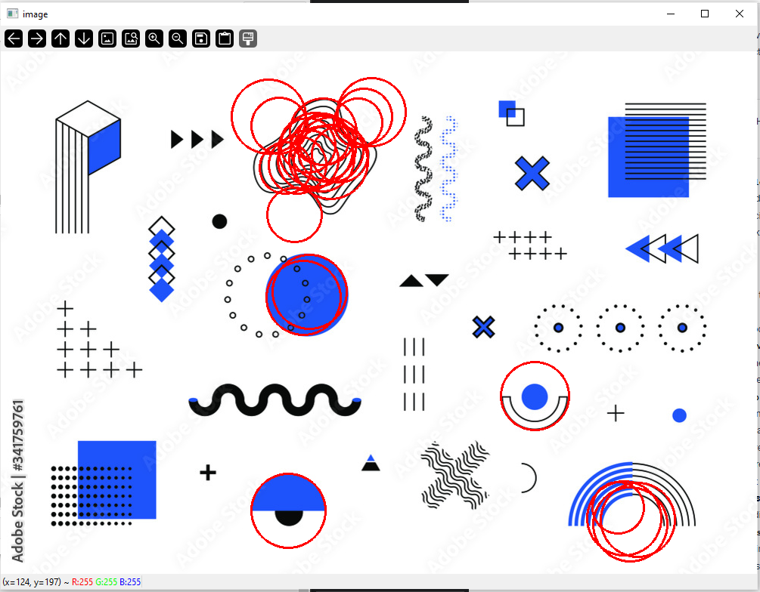

minDist=10

maxRadius=70

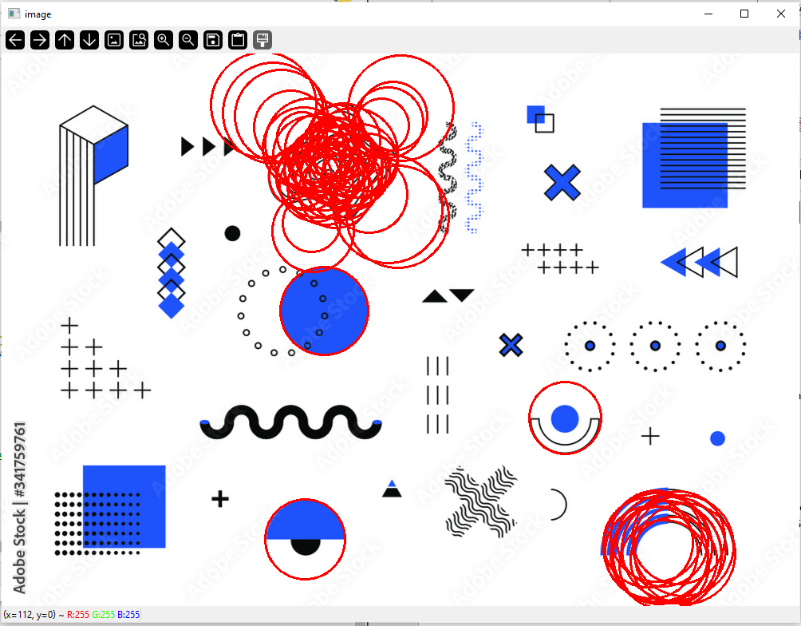

minDist=10

maxRadius=100

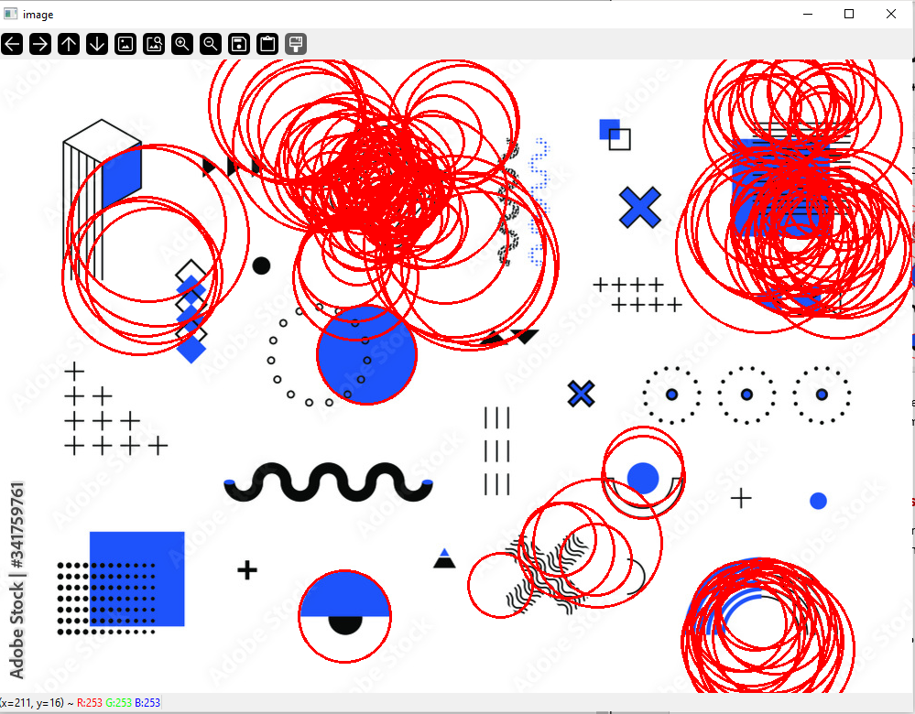

minDist=50

maxRadius=50

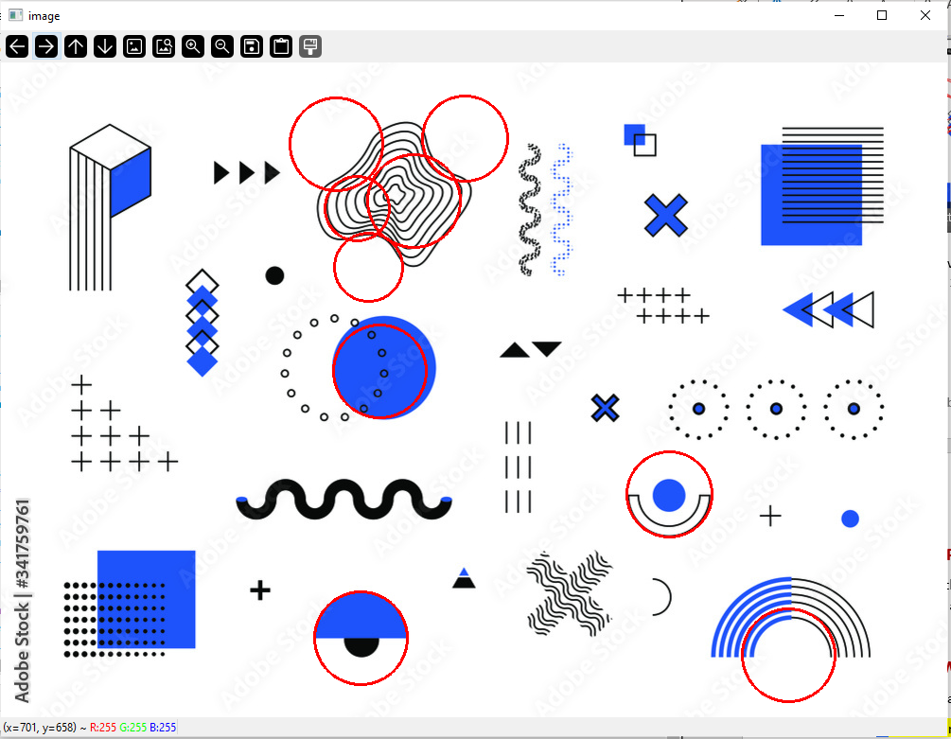

minDist=50

maxRadius=70

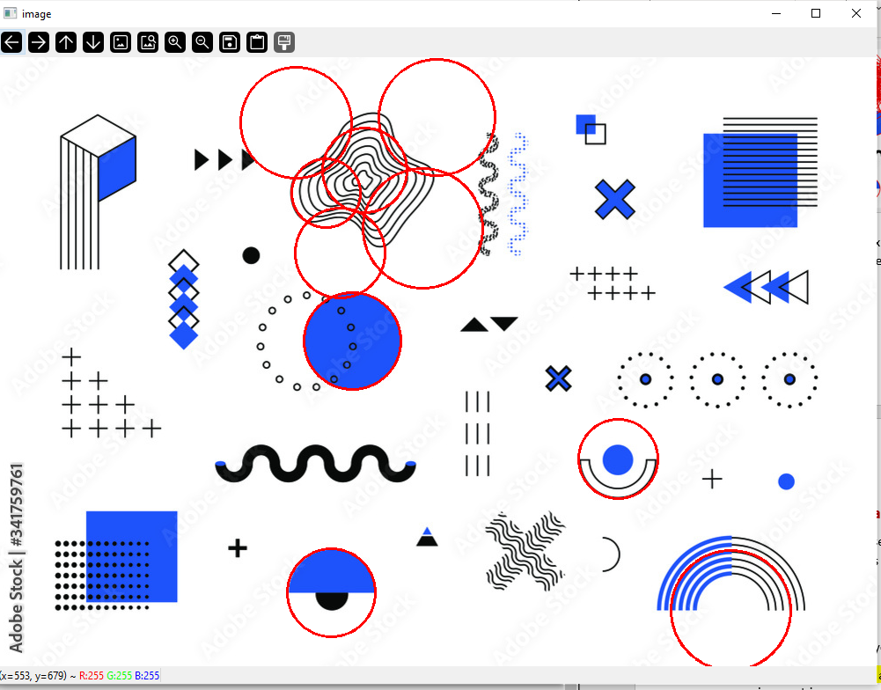

minDist=50

maxRadius=100

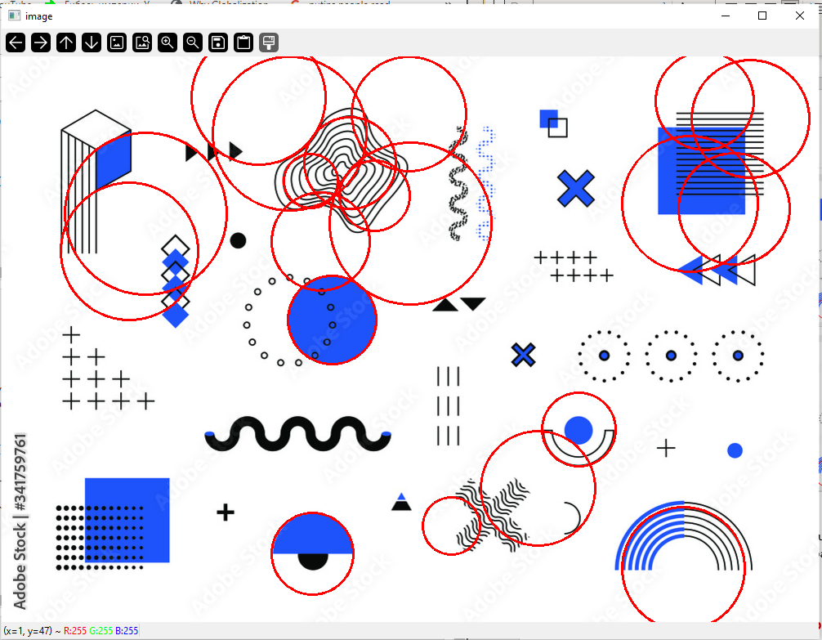

minDist=150

maxRadius=50

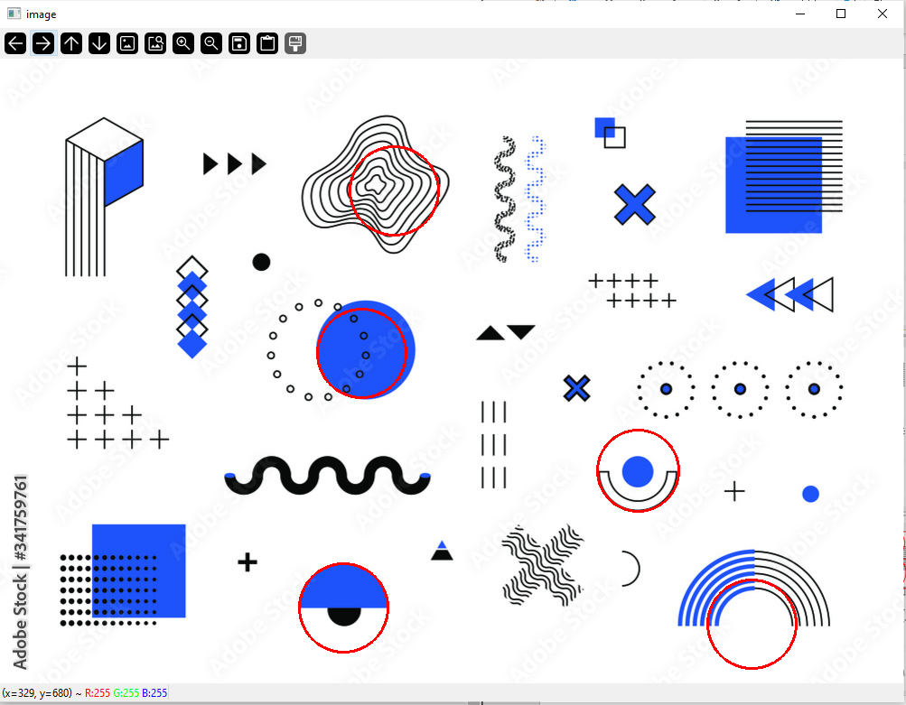

minDist=150

maxRadius=70

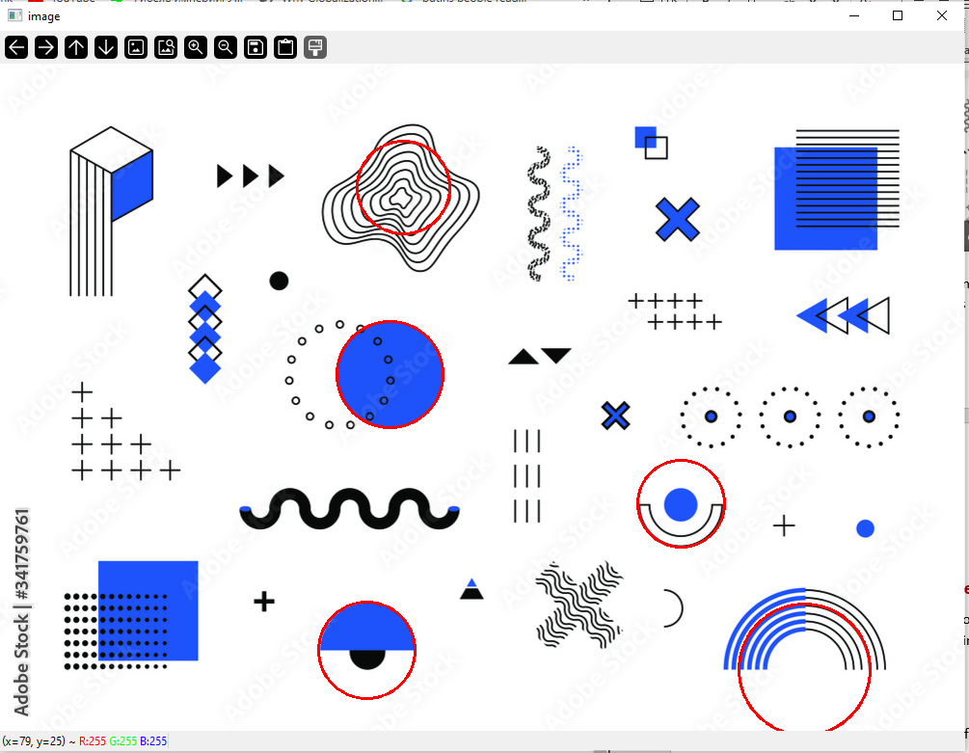

minDist=150

maxRadius=100

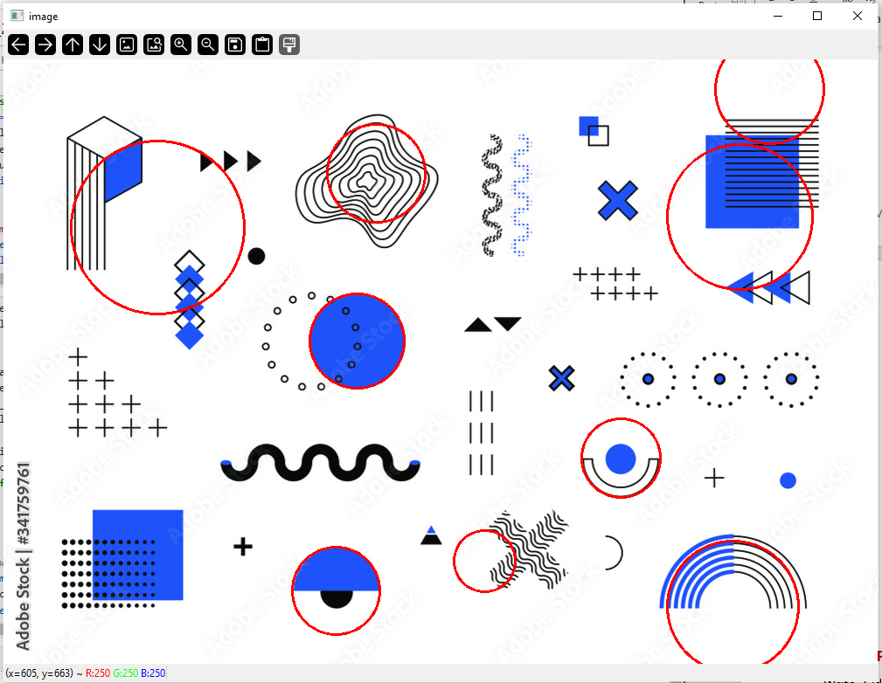

* 1. In your words, explain how would parameters in cv.HoughCircles() change the result? Choose 3 parameters for this part.

minDist specifies the minimum distance between centers of circles. The larger this parameter is, the more accurately we can detect circles far from each other. If we decrease this parameter, then we will detect closely located circles.

minRadius and maxRadius determine range of radius of circles we want to detect. So, by adjusting these parameters we can control how big or small circles we want to detect.

## **Part III: Project Proposal Preparation**

Write 3 ideas for the course project and a short description for each. Prepare to discuss your ideas and the pros and cons during the lab demos (weeks 6 or 7).

**Project Idea 1: Smart Classroom Attendance**

Description: Using face recognition to take attendance in a classroom setting. When students enter the classroom, a camera mounted at the entrance scans faces, and matches them with a pre-existing database to mark attendance automatically.

**Project Idea 2: Detect specific movie characters in TV series**

The goal of this project is to develop a system that can automatically detect and segment specific movie characters when they appear in TV series episodes. This can be useful for fans, and content creators looking to analyze character appearances or create content around their favorite characters.

**Project Idea 3: Snake game that you can control using hand gestures or eye tracking**

An interactive Snake game in which the player controls the snake's movement using hand gestures or eye tracking. (Can be any other simple game).

## **Part IV: Group Work**

1. Add this declaration to your file:

We, group 5 Davender Singh and Liliya Panfilova, declare that the attached assignment is our own work in accordance with the Seneca Academic Policy. We have not copied any part of this assignment, manually or electronically, from any other source including web sites, unless specified as references. We have not distributed our work to other students.

1. Specify what each member has done towards the completion of this work:

|  | Name | Task(s) |
| --- | --- | --- |
| 1 | Davender Singh | Part 1 |
| 2 | Liliya Panfilova | Part 2 |
| 3 | Davender Singh and Liliya Panfilova | Part 3 |